Oasis Project
Annual Report 2018-2019
28 Manor Street Plymouth PL1 1TW
Project of Plymouth Methodist Mission Circuit
Charity no. 1129521
It continues to be a pleasure and privilege to incorporate the work and ministry of Oasis within the wider part of our mission and ministry as a church. The Plymouth Mission Circuit has had a long history of serving some of the neediest people in the city of Plymouth and we are delighted that this work continues in the transforming ministry of Oasis.

As a church we are committed to the transformation of individuals, communities and the city at large, and Oasis is a key expression of this desire. It is my pleasure then to commend this report to you, which of course, represents hours of paid and volunteer hours as we endeavour to see individuals and the community of Stonehouse transformed by this ministry.
Reverend Gareth Higgs, Superintendent Minister Methodist Central Hall.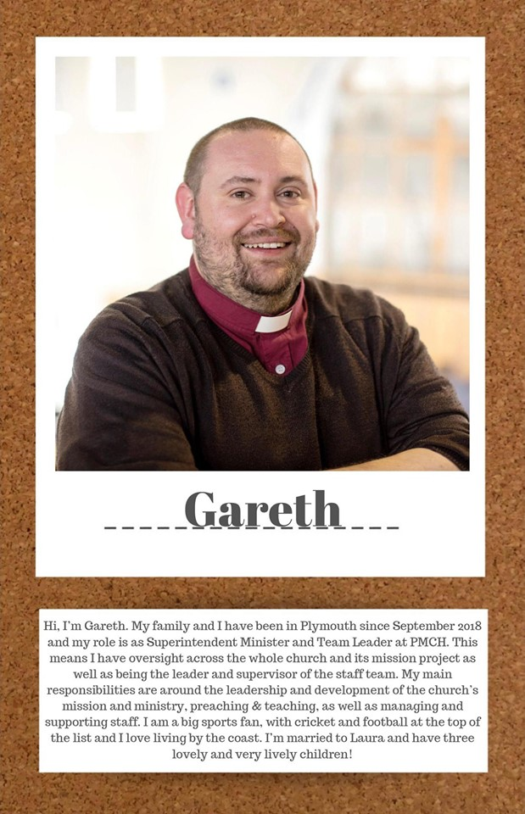

This years’ highlights
- Kev Atwood, a volunteer, held an art exhibition at the Radiant Gallery (Rumpus Cosy) to raise funds for us as a result of the support we had given him here at the centre

- A roving carol service with the Stonehouse singers, we started at the Clipper which has been transformed from a down and out pub into a community café. We processed along Union Street singing Carols. We stopped at the Palace Theatre and people stopped and joined in (dogs as well). We then went to Union Corner, heard the Christmas story, ended up in the Oasis Project for hot chocolate, mince pies and Hark the Herald Angels Sing.

- Scratch nativity at Victoria Park, we rounded up volunteers to dress up and take a part. There was communal singing and again the Nativity Story was shared.

- Hark the Herald Angels quiz around Stonehouse, we had an Angelic Host of knitted angels in shop windows, with local people going from place to place to source where each line of the chorus of Hark the Herald Angels was placed with an angel in the window.

- A new community group Adelaide Angels are meeting here, as well as a local oral history group, a trained CAT counsellor, The Deeper Life Bible Church, The Families Intensive Intervention Project, and Groundwork ran a project in the Autumn here.

- Stonehouse Action street party, which was mainly dry, and we were able to sell cakes and tell people what it was that we do at the centre.

- Maria passed her Level 4 Food Safety in Catering with merit, we continue to offer our Food Safety in Catering training. The Café and The Foodbank achieved a 5 star rating from Environmental Health.

- Together with Plymouth Foodbank we have 73 volunteers and we have had foreign students from Germany, Italy, France and Switzerland.

- We supported a couple of vulnerable adults through the difficult death of their father

- Catering for Fit and Fed a summer sports programme with a healthy lunch for 25 children delivered every day for four weeks.

- Open The Book has run in two local schools, and the local families enjoyed our Open the Book breakfast and lunch, including trips to local arts projects, the park, the Hoe and crafts in the centre.

- Thanks to Tesco bags of Help we have been able to offer free food safety courses to other charities and Hayley has done amazing cooking demos. Comments like “I never like chilli but this is good. I could make this.”

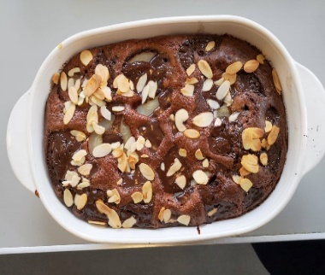

This years’ achievements
216 people have attended training in IT, Maths, Art, English, Cookery or the Job Club, or worked as a supported volunteer at the Oasis Project from September 2018 - August 2019. 41 people have gained a Level 2 in Food Safety in Catering. 6 people have gained a maths or English qualification.
17 learners/volunteers have obtained work and 9 have gone onto other volunteering roles, 12 have gone on to train elsewhere.1 person also commented that their Christian faith had developed over the year.
Of 72 learners who attended courses lasting more than a day 68% responded to a follow - up questionnaire/phone call said their confidence had improved. 65% said their everyday living skills had improved. 41.6% could evidence improved social interaction, 27.7% had felt they were now addressing addictions or mental health issues and 18% had improved their ability to cope with stress. 25% also evidenced improved ability to seek help when needed/better awareness of support available.
The computers in our café have been used 932 times for job searches and internet enquiries. Whilst there is an assumption that everyone can afford the cost of being online we know this is often something that is beyond the reach of stretched budgets.
Our printing service is appreciated and well used by the community.
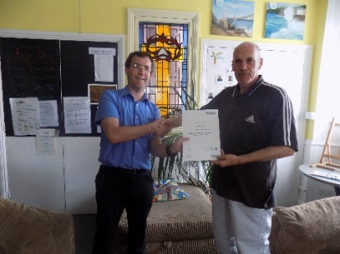 Martin receiving his certificate for Level 1 Maths.

We have a group of residents from a care home who are now coming in weekly to learn how to cook. Because they live in a care home they do not cook for themselves. But once a week they take home food that they have prepared, they either eat it for tea, or in the case of cakes and buns share with their fellow residents.
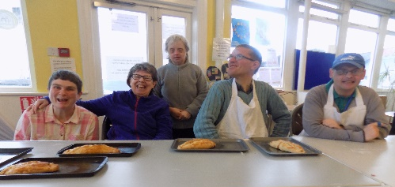
Emma, Marilyn, Judith, Glenn and David with pasties that they had made for their dinner.
Case study
Larry says after he completed the IT course he finished his sports therapy and massage course at University thanks to the help he received at Oasis and submitted all his college work on line on time. He wouldn't have been able to do this without the IT course.
Paul is now working in a restaurant, now he is earning he has bought a laptop and tablet and uses them daily
Paul enjoyed the computer course - he didn't know anything about using a computer or going online when he started and couldn't think of any way we could improve it.
Future plans
Following a review of values for the Circuit, the Oasis Committee will be re-evaluating its role in the light of these to ensure we are both working as part of the Methodist mission circuit’s aims and objectives and responding to local need.
Demand for food has increased due to the Playbarn opening opposite and we are always looking for new catering opportunities such as Fit and Fed.

Thanks to our funders and supporters both individuals and organisations
The Plymouth Astor Trust (VHS) The Plymouth and Exeter District of the

